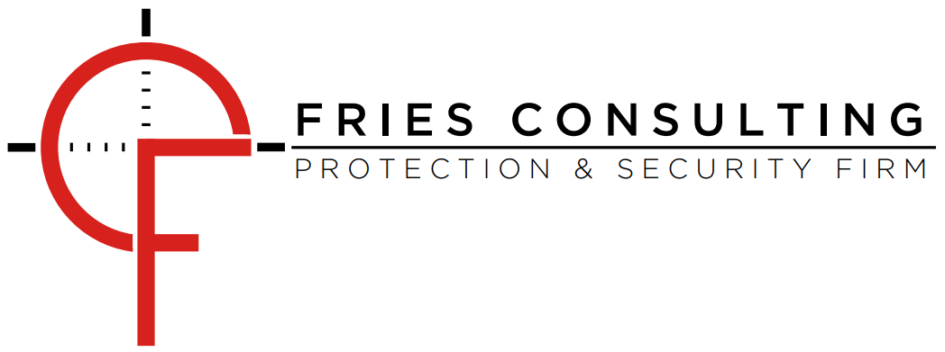

Liability Waiver

This form must be completed and signed with all rules followed by whomever participates in firearms training conducted by Fries Consulting.

Students wishing to participate in training courses (Course) will be required to complete the below Agreement prior to acceptance into any Course. The below Agreement is included for reference.
READ CAREFULLY! BY INITIALLY THIS AGREEMENT, YOU WILL BE WAIVING IMPORTANT LEGAL RIGHTS!
By signing this Liability Release and Express Assumption of Risk Agreement (“Agreement”), you are knowingly and voluntarily agreeing to the terms contained within. Furthermore, you fully recognize that you are waiving important legal rights for yourself, your family, estate, heirs, and assigns by doing so. This is an important legal document, and Fries Consulting, LLC encourages you to seek legal counsel before signing it if you do not understand any aspect of this agreement. DO NOT sign it unless you understand and agree to each and every term.
You hereby agree to fully inform your family of the potential for injury or death when participating in any firearms, less lethal, and/or scenario-based training and understand this is a legal and binding contract between the Fries Consulting, LLC (the “Released Parties”) and you as the participant (the “Participant”) in firearms, less lethal, and/or scenario-related activities consisting of a series of lessons, lectures, drills, actions, tests, and other detailed information comprising instruction on the use of firearms, less lethal tools, and/or everyday objects (hereinafter “Course”) and by signing this document on behalf of yourself, your family, estate and heirs, YOU ARE KNOWINGLY AND VOLUNTARILY GIVING UP ALL RIGHTS TO SUE THE RELEASED PARTIES SET FORTH BELOW FOR STRICT PRODUCT LIABILITY, NEGLIGENCE OR ANY OTHER LEGAL CLAIM SHOULD YOU BE INJURED OR KILLED AS A RESULT OF PARTICIPATING IN THE COURSE.
Please read each paragraph carefully. Your signature indicates you understand and agree to all of the information and terms contained therein. As lawful consideration for being permitted to enter the property and shooting range and/or use equipment and to engage in and/or observe shooting and other activities as a Participant, I attest that the following answers are true and correct:
ASSUMPTION OF THE RISKS AND RELEASE. Participant expressly acknowledges that training with live ammunition is inherently dangerous and that there is no possible way that Fries Consulting, LLC, its employees, or its agents can provide a totally safe environment for the Course. Participant acknowledges that attending and participating in the Course will enhance Participant’s exposure to risk of injury occasioned by carelessness of the Instructor and other Course participants. The Participant risks serious bodily injury and harm that includes risk of death or dismemberment. Participant hereby assumes the risk of any and all injury that may result in participation in the Course.
I, on behalf of myself, my executors, heirs, successors, and assigns, hereby agree to release, discharge, waive, and relinquish any and all legal claims, including, without limitation, claims for strict product liability and/or negligence, that could be asserted against Fries Consulting, LLC and all of their officers, employees, volunteers, agents, assigns, directors, board members, parent and subsidiary companies, and affiliates (hereinafter the “Released Parties”), should I sustain loss or damage or be injured or killed in connection with participating in associated firearms related activities (Course) whether caused by the fault of myself, my family, Fries Consulting, LLC, or any other third parties.
INDEMNIFICATION. Participant hereby absolves Fries Consulting, LLC, of any damages Participant may experience in participating in the Course. Participant agrees to hold Fries Consulting, LLC, its employees and its agents harmless from any sort of injury or damage experienced by Participant in taking the Course. Participant expressly waives any and all rights and causes of action Participant may have for compensation at law and equity, including negligence, from Fries Consulting, LLC, its employees or its agents in such event that the participant is injured and shall indemnify the same.
I agree to indemnify and defend Fries Consulting, LLC, against all claims, causes of action, damages, judgments, costs or expenses, including attorney fees and other litigation costs, which may in any way arise from my or my family's use of or presence upon the training facilities.
FEES. I agree to pay for all damages to any property, equipment, or facilities caused by any negligent, reckless, or willful actions by me or my family.
WARRANTY. I understand the Released Parties provided a venue for these activities without any express or implied warranties of merchantability or fitness for a particular use or purpose, and that the activities I participate in at the Course are hereby accepted in “as is” condition by me.
AGREEMENT TO FOLLOW DIRECTIONS. Participant will follow all directions given by Fries Consulting, LLC, agent (the “Instructor”) for the duration of the Course. Participant acknowledges that such directions are vital for the safety of all Course participants. Failure to follow directions from the instructor may result in participant’s ejection from the Course without refund of any monies paid to Fries Consulting, LLC, for participant’s attendance.
NO DURESS. Participant acknowledges that the Course, though beneficial, is not a necessity and that similar courses are offered by other entities. Participant is under no physical or economic compulsion from Fries Consulting, LLC, to engage in this particular Course or to sign this Waiver.
APPLICABLE LAW. Any legal or equitable claim that may arise from participation in the above shall be resolved under Indiana law.
ARM'S LENGTH AGREEMENT. This Agreement and each of its terms are the product of an arm's length negotiation between the Parties. In the event any ambiguity is found to exist in the interpretation of this Agreement, or any of its provisions, the Parties, and each of them, explicitly reject the application of any legal or equitable rule of interpretation which would lead to a construction either "for" or "against" a particular party based upon their status as the drafter of a specific term, language, or provision giving rise to such ambiguity.
ENFORCEABILITY. The invalidity or unenforceability of any provision of this Agreement, whether standing alone or as applied to a particular occurrence or circumstance, shall not affect the validity or enforceability of any other provision of this Agreement or of any other applications of such provision, as the case may be, and such invalid or unenforceable provision shall be deemed not to be a part of this Agreement.
DISPUTE RESOLUTION. The parties will attempt to resolve any dispute arising out of or relating to this Agreement through friendly negotiations amongst the parties. If the matter is not resolved by negotiation, the parties will resolve the dispute using the below Alternative Dispute Resolution (ADR) procedure.
Any controversies or disputes arising out of or relating to this Agreement will be resolved by binding arbitration under the rules of the American Arbitration Association. The arbitrator's award will be final, and any judgment may be entered upon it by any court having proper jurisdiction.
TERM. Participant agrees and acknowledges that the terms and conditions of this Agreement shall continue in force and effect now and in the future and all times during which Participant participates in the activities covered by this Agreement, and shall be binding upon Participants heirs, executors, administrators, personal representatives, and/or anyone else claiming on Participants behalf.
PARENT/GUARDIAN (MINORS). As applicable, Participant agrees that all minors (individuals under the age of 18) that attend, participate, or observe the Course must be accompanied by their parent or legal guardian, who must provide express authorization on behalf of such minors. Participant represents as the parent or legal guardian of any minor accompanying Participant that they provide express authorization for such minor’s attendance and participation. Participant understands that all of the provisions of this Liability Release and Express Assumption of Risk Agreement are fully applicable to all such minors that accompany Participant and Participant provides a full waiver and release of all liability with respect to such minor(s).
Participant understands that the Released Parties will in no way be responsible for any harm, injury, or damage that occurs to any minor under Participant's care and that Participant is fully responsible for ensuring any such accompanying minor’s safety in all respects. Participant will abide by all laws, regulations, and requirements concerning such minor’s handling or usage of any firearms and Participant is fully responsible for ensuring such compliance, including but not limited to any age prohibitions or licensing and permitting requirements. On behalf of any minor accompanying Participant, Participant fully releases the Released Parties and waives all legal claims concerning such minor that may otherwise arise from or result from Participant bringing such minor to the Course, which shall include every waiver and release outlined in this agreement concerning Participant and is made applicable to such minor to the furthest extent of the law.
STUDENT BACKGROUND. I certify that my answers in Sections “1.” to “14.” below are true, correct, and complete. I have read and understand the Notices, Instructions, and Definitions in entirety. The information you provide in response to the Sections below will be used to determine whether the Participant is prohibited from receiving instruction and attending the Course. Only upon completing and signing this Agreement is the Participant able to attend or participate in the desired Course. Participant also understands that making any false oral or written statement, or exhibiting any false or misrepresented identification with respect to these responses may also violate Federal, State and/or local law.
Participant (hereinafter “You”) states that he/she is over 18 years of age. (If under the age of 18, A legal guardian must sign and accompany the participant to the course). You ARE a United States Citizen or Legal Permanent Resident that is lawfully able to own firearms and participate in firearms related activities.
The United States International Traffic and Regulation (ITAR) AND Export Administration Regulations (EAR) prohibit non-U.S. Citizens from receiving military skills training, such services include CQB tactics, individual or group tactical movement and combat (i.e. move, cover, shoot), mounted operations, structure/room clearing techniques, night operations with assistive equipment, among others that are at times included within Fries Consulting, LLC, Course Curriculums.
You ARE familiar with and understand the rules of basic firearms safety and the potential consequences of not following these rules and You ARE in possession of the proper training and/or experience in the handling and use of firearms necessary to freely and voluntarily assume any and all risks of participating in firearms related activities.
You ARE of stable and sound mind and legally able to possess, train with, and use firearms.
You do NOT have a physical infirmity that is a contraindication to firearms training, moving over uneven ground or being exposed to weather, sun, rain, dust or other environmental exposures that may be encountered during firearms related activities.
You are NOT under indictment or investigation in any court for felony, or any other crime, for which the judge may imprison you for more than one year, even if you received a shorter sentence including probation and/or are you are NOT a current member of the military who has been charged with violation(s) of the Uniform Code of Military Justice and whose charge(s) have been referred to a general court-martial.
You have NOT been convicted in any court of a misdemeanor crime of domestic violence, and/or you have NOT been a member of the military and been convicted of a crime that included, as an element, the use of force against a person.
You are NOT a fugitive from justice.
You have NOT been adjudicated mentally defective and/or you have NOT ever been committed to a mental institution.
You are NOT currently taking any prescription antidepressant, anxiety, or pain management substances/drugs and/or you are NOT an unlawful user of, or addicted to, marijuana or any depressant, stimulant, narcotic drug, or any other controlled substance.
You have NOT been dishonorably discharged from the Armed Forces of the United States of America.
You have NOT renounced your United States citizenship.
You have NOT been convicted of a misdemeanor crime of Domestic violence.
You are NOT subject to a court order (including a Military Protection Order issued by a military judge or magistrate) restraining order for harassing, stalking or threatening any person.
You WILL allow Fries Consulting, LLC to use any and all photographs, videos, and/or electronic media collected during Course for future promotions, documentation, and social media. (At your verbal request Fries Consulting, LLC will do every effort possible to obscure your face/identifying characters if desired).
You will NOT use material taught by Fries Consulting, LLC for illegal gains and/or criminal intent.

I HAVE READ THIS DOCUMENT AND UNDERSTAND IT. I FURTHER UNDERSTAND THAT BY INITIALLY THIS RELEASE, I VOLUNTARILY SURRENDER CERTAIN LEGAL RIGHTS.

